1. Which plant generation is diploid?
*a. sporophyte
b. gametophyte

2. Spores are
*a. haploid
b. diploid
c. partly haploid and partly diploid

3. Gametes are
*a. haploid
b. diploid
c. partly haploid and partly diploid

4. Ferns have vascular tissue.
*a. true
b. false

5. When you look at a "typical" fern plant, you are looking at the
*a. sporophyte generation
b. gametophyte generation

6. In ferns, how do sperm reach the eggs?
*a. They swim.
b. They are carried in pollen.
c. They are carried in fruit.

7. How do ferns disperse to new habitats?
a. By swimming
*b. By spores
c. By seeds

8. Fern spores are formed by
a. mitosis
*b. meiosis
c. both mitosis and meiosis

9. Fern gametes are formed by
*a. mitosis
b. meiosis
c. both mitosis and meiosis
10. On the fern plant diagram below, the structure labeled “a” is the
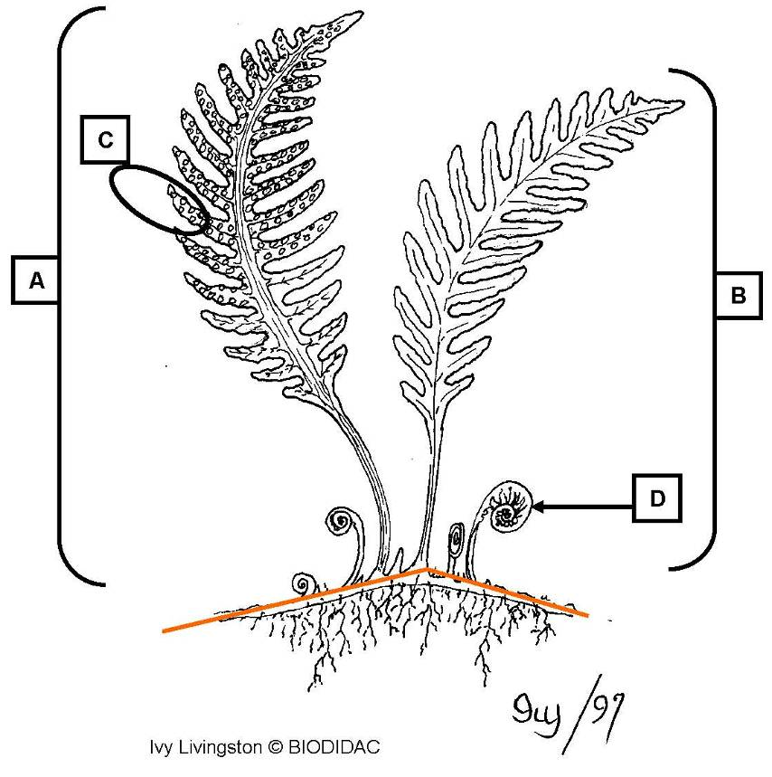

a. fiddlehead
b. sori
*c. sporophyll
d. stem (rhizome)
e. vegetative leaf

11. On the fern plant diagram below, the structure labeled “b” is the

a. fiddlehead
b. sori
c. sporophyll
d. stem (rhizome)
*e. vegetative leaf

12. On the fern plant diagram below, the structure labeled “c” is the

a. fiddlehead
*b. sori
c. sporophyll
d. stem (rhizome)
e. vegetative leaf

13. On the fern plant diagram below, the structure labeled “d” is the

*a. fiddlehead
b. sori
c. sporophyll
d. stem (rhizome)
e. vegetative leaf

14. On the fern plant diagram below, the orange lines represent the

a. fiddlehead
b. sori
c. sporophyll
*d. stem (rhizome)
e. vegetative leaf

15. On the fern spore-producing structures diagram below, the structure labeled “a”
is the
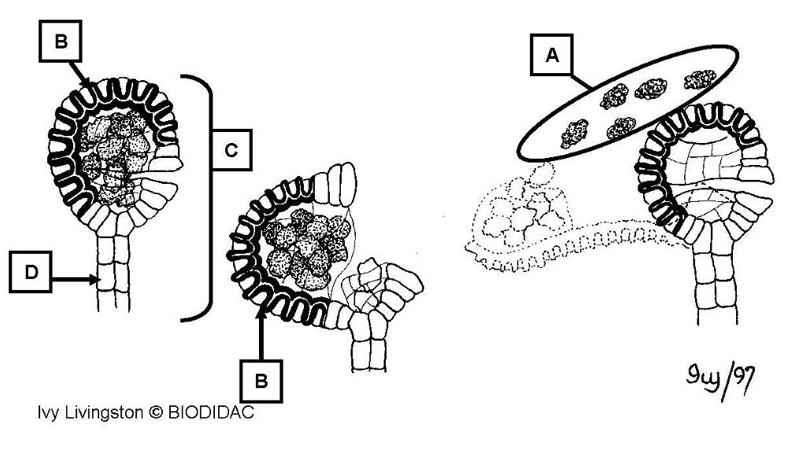

a. annulus
b. sorus
c. sporangium
*d. spores
e. stalk

16. On the fern spore-producing structures diagram below, the structure labeled “b”
is the

*a. annulus
b. sorus
c. sporangium
d. spores
e. stalk

17. On the fern spore-producing structures diagram below, the structure labeled “c”
is the

a. annulus
b. sorus
*c. sporangium
d. spores
e. stalk

18. On the fern spore-producing structures diagram below, the structure labeled “d”
is the

a. annulus
b. sorus
c. sporangium
d. spores
*e. stalk

19. On the fern diagram below, the structure labeled “a” is the
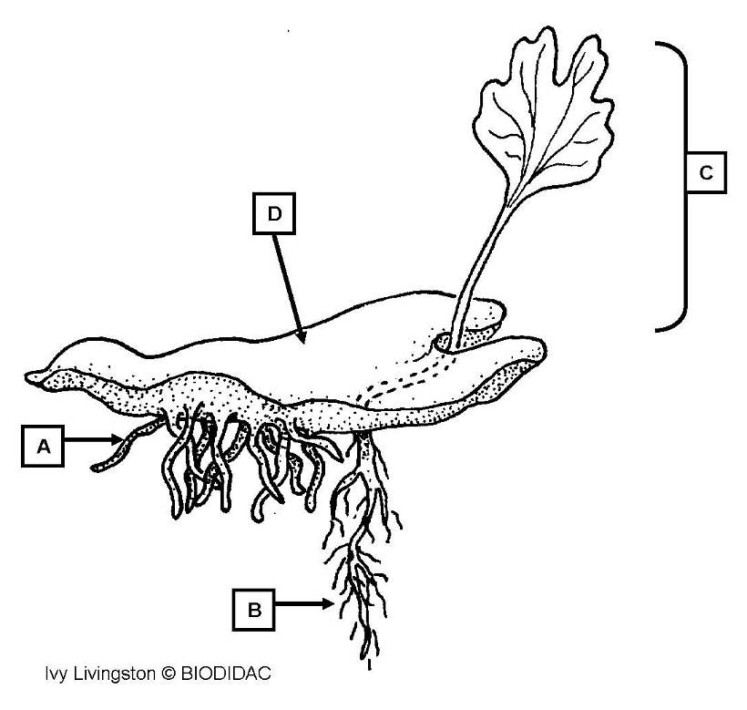

a. gametophyte
b. sporophyte
*c. rhizoids
d. roots

20. On the fern diagram below, the structure labeled “b” is the

a. gametophyte
b. sporophyte
c. rhizoids
*d. roots

21. On the fern diagram below, the structure labeled “c” is the

a. gametophyte
*b. sporophyte
c. rhizoids
d. roots

22. On the fern diagram below, the structure labeled “d” is the

*a. gametophyte
b. sporophyte
c. rhizoids
d. roots

23. On the fern diagram below, the structure labeled “a” is the
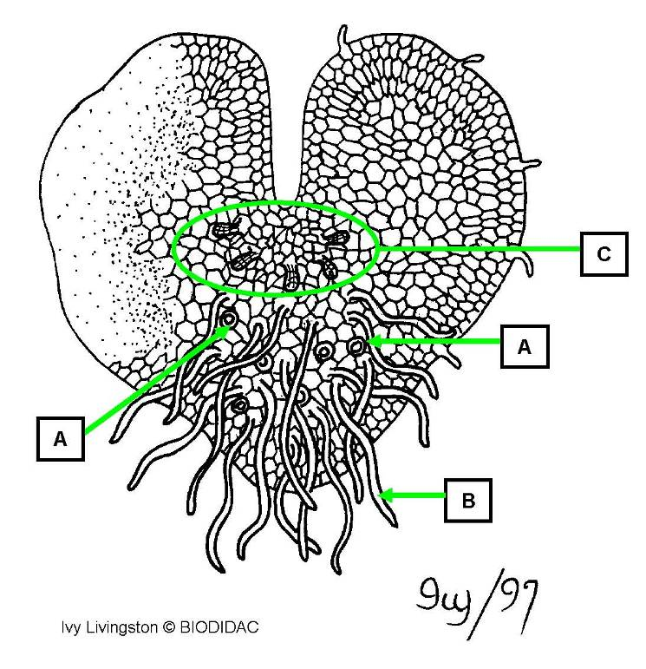

a. archegonia
*b. antheridia
c. immature prothallus
d. mature prothallus
e. rhizoids

24. On the fern diagram below, the structure labeled “b” is the

a. archegonia
b. antheridia
c. immature prothallus
d. mature prothallus
*e. rhizoids

25. On the fern diagram below, the structure labeled “c” is the

*a. archegonia
b. antheridia
c. immature prothallus
d. mature prothallus
e. rhizoids

26. This is a diagram of what fern generation?

*a. gametophyte
b. sporophyte

27. On the fern diagrams below, which is an immature prothallus?
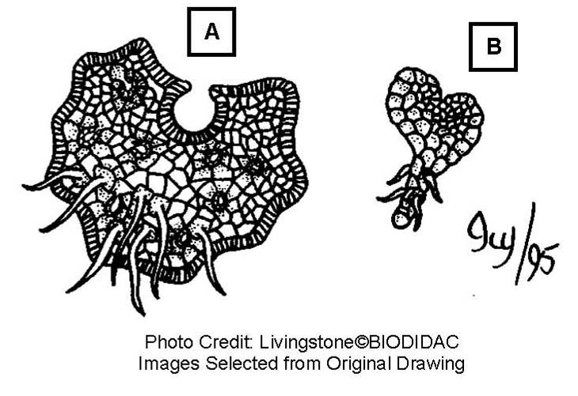

a. A
*b. B

28. On the fern diagrams below, which is a mature prothallus?

*a. A
b. B

